Ideation phase
Empathize& Discover
Date | 2November2025
Team ID | NM2025TMID02619
Project Name | Calculating family Expenses using service now
Maximum Marks | 4Marks

Empathy Map Canvas
In the Empathize & Discover phase, the team observed how family members and household managers currently manage their daily and monthly expenses. They discovered that many people struggle with tracking where their money goes, often forgetting to record small transactions or misplacing paper receipts.
Through interviews and observations, it became clear that this leads to budget mismanagement, overspending, and lack of visibility into financial patterns. Some users feel anxious when they can’t recall how funds were spent, while others feel frustrated by the effort needed to calculate totals manually each month.
By understanding these emotional and practical challenges, the team realized the need for an automated, digital platform that can record, categorize, and visualize expenses in real-time. ServiceNow provides an ideal foundation for this by offering form automation, workflow management, and analytics dashboards.
Gathering these insights helped the team recognize that a user-friendly, automated, and accurate expense tracking solution would greatly reduce stress and improve financial awareness within families.
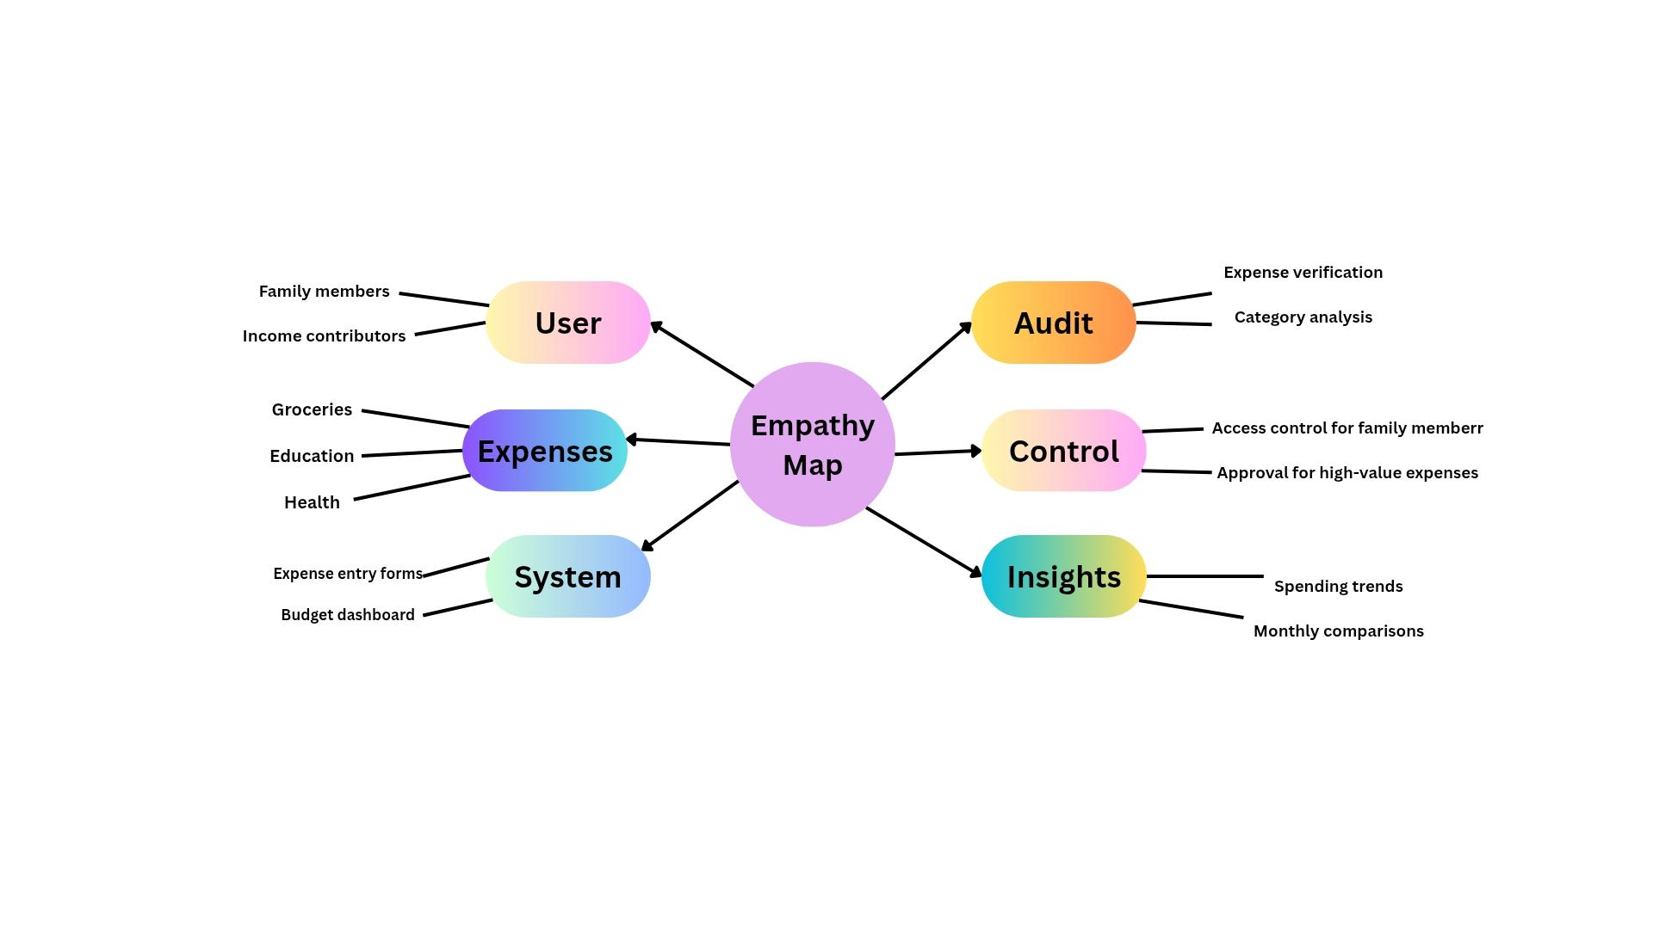
Example
Reference: https://www.canva.com/design/DAG3ixtJyzg/XpaBKGeKVctrJ_eXwD8Zaw/edit?utm_content=DAG3ixtJyzg&utm_campaign=designshare&utm_medium=link2&utm_source=sharebutton

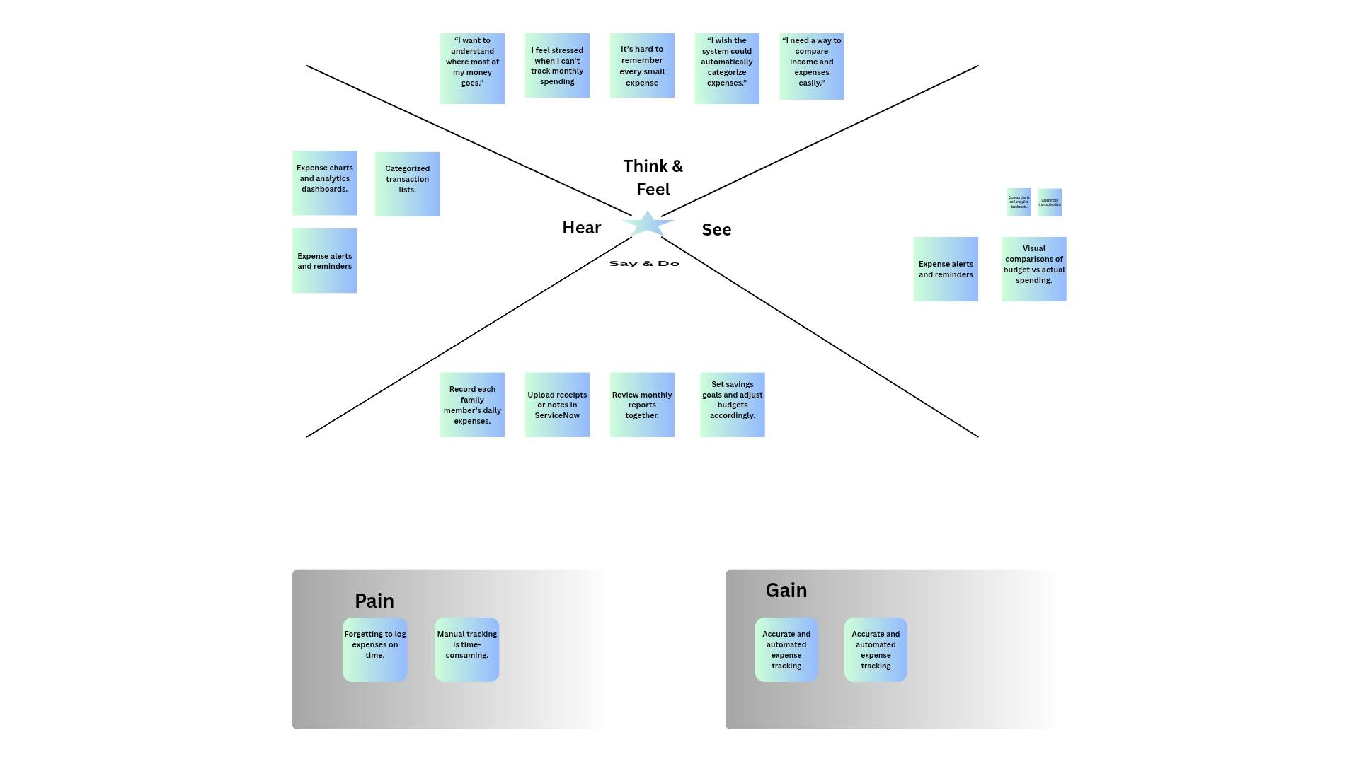
Example: Calculating Family Expenses using ServiceNow

The empathy map for the Family Expense Tracking Application highlights that users want to understand where their money goes and often feel stressed when they can’t track monthly spending. They find it difficult to remember every small expense and wish the system could automatically categorize and compare income and expenses. Users frequently hear about expense charts, analytics dashboards, and reminders as helpful tools and see visual comparisons of budgets versus actual spending. They tend to record daily expenses, upload receipts, review monthly reports, and set savings goals together as a family. However, they experience pain points such as forgetting to log expenses and finding manual tracking time-consuming. The main gains they seek are accurate, automated expense tracking and simplified monitoring of their family budget.

